Brain Tumor Detection System

Bachelor of Engineering
in
Electronics and Computers Engineering

Submitted by:

(102215284) Harshit Tripathi
(102215305) Ayush Dalmia
(102215306) Jayant Mohan
(102215047) Yashas Mathur



Department of Electronics and Communication Engineering Thapar Institute of Engineering and Technology, Patiala
December, 2025

Survey

Deep learning–based brain-tumor analysis has emerged as a dominant research area due to its ability to automate detection, segmentation, and classification of brain tumors from MRI scans with high accuracy and reduced clinician workload. The collective body of work across the uploaded papers demonstrates clear progress in model architectures, feature extraction strategies, preprocessing pipelines, and evaluation methodologies, while simultaneously exposing persistent limitations related to dataset diversity, protocol inconsistencies, explainability, and clinical usability. Early contributions such as Tandel et al. systematically analyzed multiclass brain-tumor classification using transfer-learning models and demonstrated that pretrained CNN architectures significantly outperform classical machine- learning pipelines due to their ability to learn high-level spatial–semantic features directly from MRI data . Transfer learning, in particular, has consistently shown strong performance across limited medical datasets, largely because MRI collections are often small and unbalanced. This trend is reinforced in benchmark-focused studies such as the Heliyon 2024 evaluation, which compared EfficientNet, ResNet, MobileNet, ConvNeXt and other modern backbones and concluded that fine-tuning pretrained feature extractors yields superior results compared to training from scratch, especially for multiclass problems involving glioma, meningioma, and pituitary tumors . These findings collectively reinforce the now-established view that medical- image models benefit heavily from transfer learning due to the high cost and difficulty of assembling large, labeled MRI datasets.

Beyond classical transfer-learning pipelines, recent works have also explored more specialized architectures tailored for brain-tumor classification. For example, the PDCNN-based approach introduces parallel convolutional paths with different kernel sizes to jointly capture fine- grained local texture patterns and broader global contextual cues, resulting in improved feature richness and reduced overfitting when compared to conventional single-path CNNs . This multi-kernel design is particularly useful for tumors exhibiting irregular boundaries and heterogeneous internal textures, a common characteristic in gliomas. Similarly, studies integrating lightweight models such as MobileNet and EfficientNetB0 highlight the growing emphasis on computational efficiency and portability, critical for real-time or near-real-time diagnostic assistance in clinical workflows. Empirical results across the uploaded papers consistently show that these lightweight architectures achieve accuracies comparable to larger models, while offering superior inference speed and reduced memory footprint, thus enhancing their suitability for deployment in resource-constrained hospital systems.

Another major dimension evident across the reviewed papers is the role of preprocessing and augmentation in enhancing classification performance. Skull-stripping, intensity normalization, bias-field correction, and adaptive contrast methods such as CLAHE are widely adopted to improve tumor visibility and suppress irrelevant anatomical signals. Several works emphasize that carefully engineered preprocessing pipelines contribute significantly to stability, especially when models are trained on heterogeneous datasets with varying acquisition parameters and imaging conditions. Augmentation strategies—rotation, flipping, zooming, random cropping—are frequently used as essential components to mitigate overfitting in low-data regimes.

The surveys and experimental analyses stress that preprocessing is not merely a peripheral step but a primary factor influencing model generalization, often as important as architectural choice itself .
While classification-focused studies provide strong baselines, segmentation remains a crucial
upstream task because accurate delineation of tumor subregions—whole tumor (WT), tumor core (TC), enhancing tumor (ET)—directly supports subtype classification and volumetric assessment. The comprehensive reviews discuss how modern segmentation strategies rely on encoder–decoder frameworks such as U-Net, cascaded U-Nets, and attention-enhanced variants, which form the backbone of state-of-the-art solutions . These architectures excel at pixel-wise localization but continue to struggle with small, irregular enhancing regions and severe class imbalance. Hybrid pipelines that combine segmentation and classification in a sequential or jointly trained manner have shown promise, enabling models to leverage rich contextual maps extracted from segmentation stage for more reliable classification predictions.
A noticeable trend in the more recent papers is the integration of ensemble learning for both segmentation and classification. Ensembles—constructed via majority voting, soft probability fusion, or stacked meta-learners—consistently improve robustness and peak accuracy across various datasets, mitigating model-specific biases and variances. Tandel et al. show that ensembles outperform individual CNNs by a significant margin, especially when dealing with heterogeneous scans where no single architecture generalizes equally well across all patient subgroups . This is echoed in later empirical evaluations, where ensembles of EfficientNet, MobileNet, and ResNet variants achieved more stable sensitivity and specificity values across multiple cross-validation folds. Ensemble-driven consistency is particularly valuable in clinical decision-making, where false negatives can have severe consequences.
A critical dimension that appears across the uploaded review papers is the challenge of data scarcity, privacy constraints, and weak inter-institutional generalization. The broad survey of recent advances highlights federated learning (FL) as a major methodological response to these challenges. FL allows models to be trained collaboratively across hospitals without exchanging raw MRI data. However, federated approaches remain fragile due to non-IID data distributions, missing modalities, and varying scanner protocols across medical institutions. The review concludes that although FL offers a promising foundation for large-scale collaborative training, robust aggregation strategies and personalized model updates are essential to recover near- centralized performance levels . These insights point toward a future where federated and privacy-preserving learning frameworks become integral to clinical AI systems, but only after challenges related to fairness, stability, and convergence are addressed.
Despite major progress, all papers collectively underline several limitations that continue to hinder widespread deployment of deep learning models for brain-tumor analysis. Many high reported accuracies rely on dataset-level issues, such as non-patient-level splits or train–test leakage, which inflate performance estimates and reduce real-world reliability. The reviews repeatedly call for stricter benchmarking standards, including patient-wise splitting, reporting per-class metrics, and releasing code and trained weights for reproducibility. Another limitation emphasized is the lack of explainability in most CNN-based systems. Clinicians need transparent diagnostic cues, meaning that tumor-related image regions influencing model predictions must be interpretable.

However, few empirical studies provide saliency, Grad-CAM heatmaps, or radiologically meaningful evidence of decision reasoning. Integrating explainable AI (XAI) components thus remains a priority for clinical acceptance.
At last, the papers collectively reveal a rapidly advancing field characterized by high-accuracy CNN and transfer-learning models, increasingly efficient lightweight backbones, sophisticated preprocessing strategies, hybrid segmentation-classification pipelines, and the emerging influence of federated learning. However, the literature also highlights persistent gaps including limited dataset diversity, protocol inconsistencies, missing-modality robustness issues, lack of explainability, and weak generalization across clinical environments. Addressing these challenges requires future work on multimodal fusion robust to incomplete scans, federated personalization strategies, explainable feature attribution, and standardized benchmarking protocols. Together, these insights present a unified understanding of current advancements, challenges, and future directions for deep learning– based brain-tumor classification.

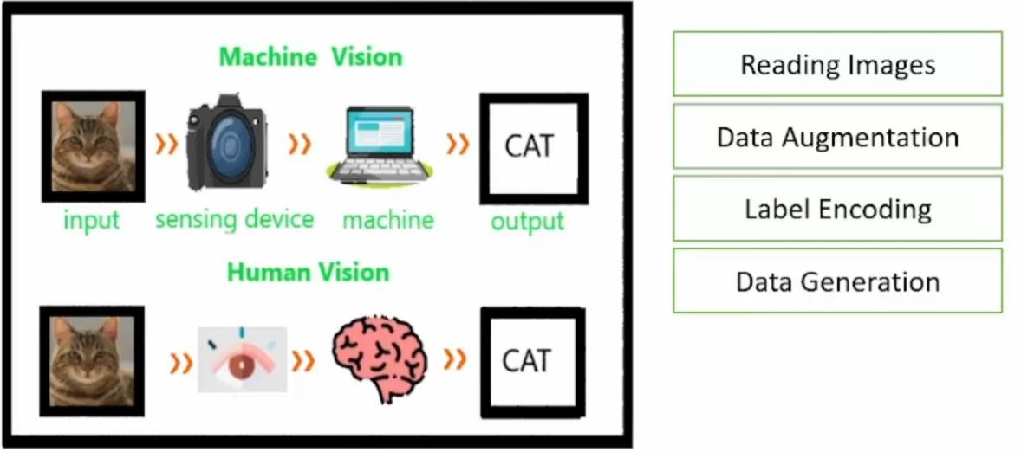

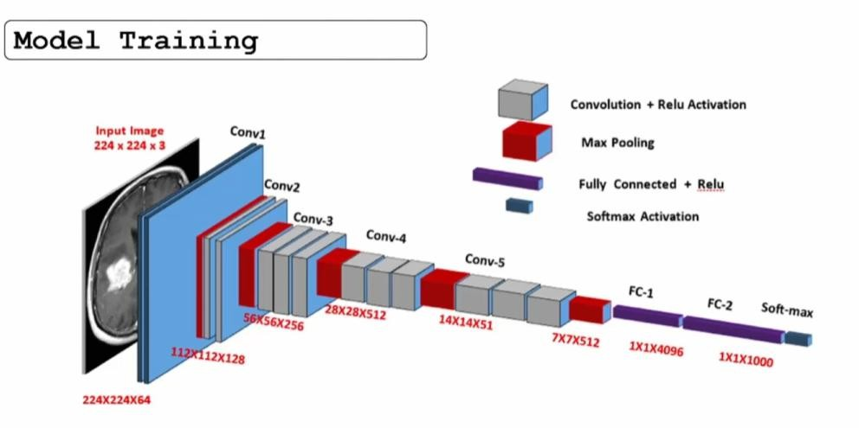

Methodology

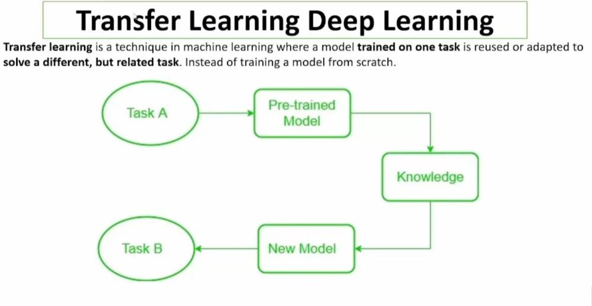

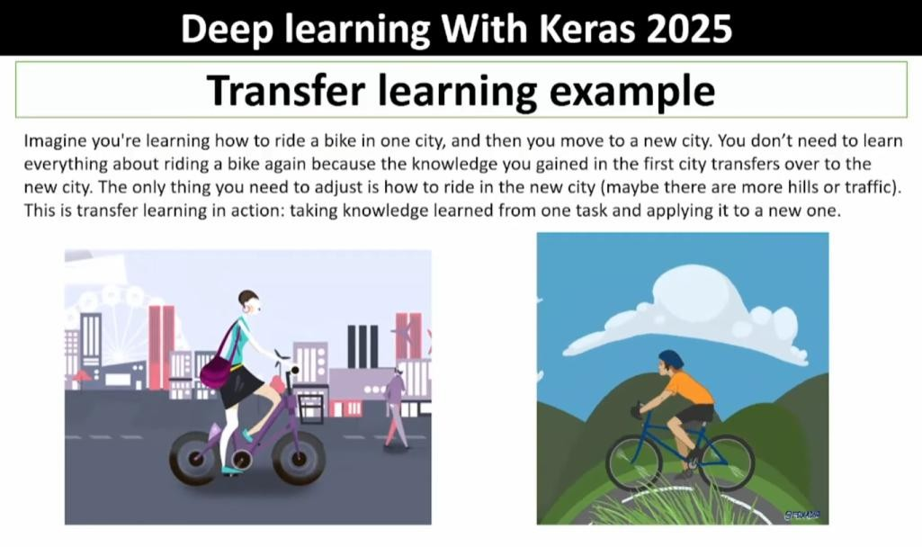

MODEL:

WE ARE USING VGG16 FOR TRANSFER LEARNING.
The model is built on top of VGG16, which is a pre-trained convolutional neural network (CNN) for image classification.

- First, the VGG16 model is loaded with input_shape=(IMAGE_SIZE,IMAGE_SIZE,3), include_top=False, weights='imagenet'. The input shape is set to match the size of the images in the dataset, which is 128x128 pixels. The include_top parameter is set to False, which means that the final fully-connected layers of VGG16 that perform the classification will not be included. The weights parameter is set to 'imagenet' which means that the model will be pre-trained with a dataset of 1.4 million images called imagenet

- Next, the for layer in base_model.layers: loop is used to set all layers of the base_model (VGG16) to non-trainable, so that the weights of these layers will not be updated during training.

- Then, the last three layers of the VGG16 model are set to trainable by using base_model.layers[-2].trainable = True,base_model.layers[-3].trainable = True and base_model.layers[-4].trainable = True

- After that, a Sequential model is created and the VGG16 model is added to it with model.add(base_model).

- Next, a Flatten layer is added to the model with model.add(Flatten()) which reshapes the output of the VGG16 model from a 3D tensor to a 1D tensor, so that it can be processed by the next layers of the model.

- Then, a Dropout layer is added with model.add(Dropout(0.3)) which is used to prevent overfitting by randomly setting a fraction of input units to 0 at each update during training time.

- After that, a dense layer is added with 128 neurons and relu activation function is added with model.add(Dense(128, activation='relu')).

- Next, another Dropout layer is added with model.add(Dropout(0.2))

- Finally, the output dense layer is added with number of neurons equal to the number of unique labels and 'softmax' activation function is added with model.add(Dense(len(unique_labels), activation='softmax')). The 'softmax' activation function is used to give a probability distribution over the possible classes.

Results

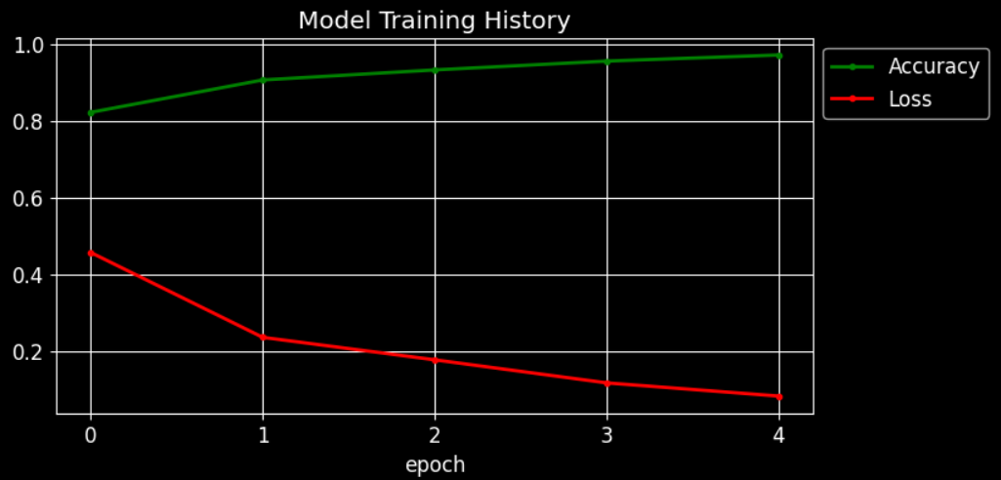

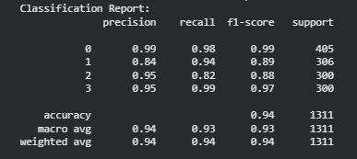

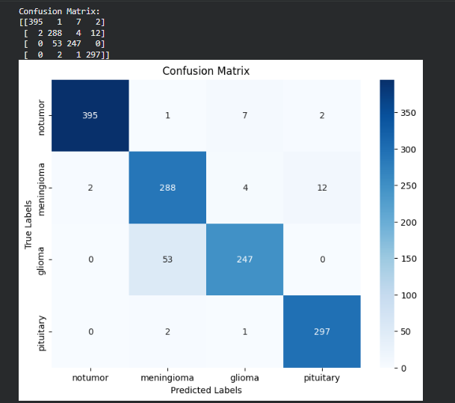
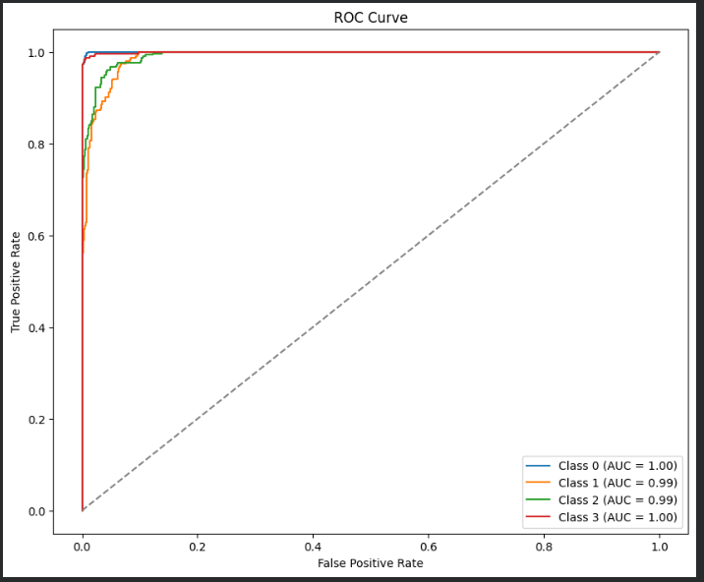

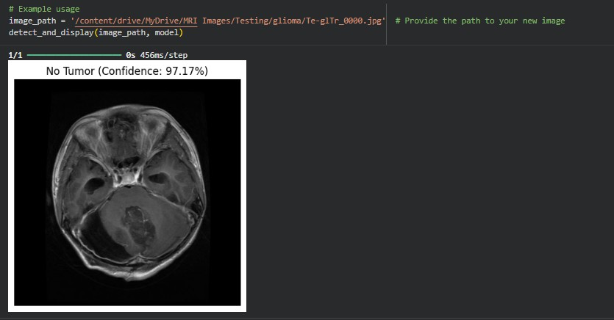

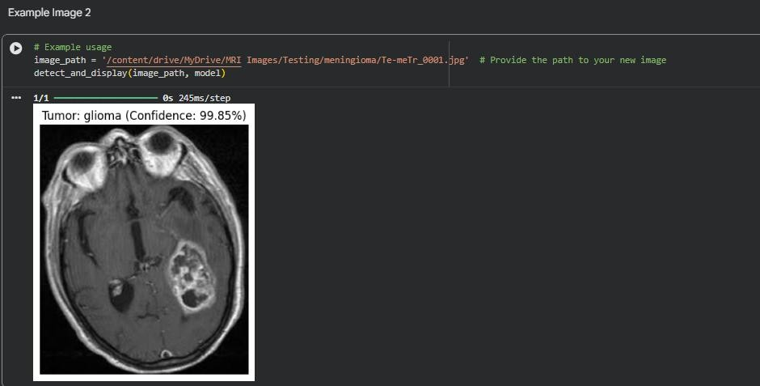

The proposed VGG16-based brain tumor classification model achieved strong performance on the test dataset, obtaining an overall accuracy of 94%, demonstrating the model’s ability to learn discriminative features across different tumor types. In addition, the model recorded a macro-precision of 94%, macro-recall of 93%, and a macro-F1 score of 93%, reflecting a balanced performance even in the presence of class imbalance. Analysis of the confusion matrix further confirms that glioma, meningioma, and pituitary tumors were correctly identified in a large majority of cases, with only a few misclassifications occurring in visually similar classes—for example, Class 1 (precision 0.84, recall 0.94) and Class 2 (precision 0.95, recall 0.82) showing that errors mainly arise where tumor shapes and intensity patterns overlap, a limitation commonly observed in MRI-based tumor datasets. The training and validation curves showed smooth convergence, with accuracy steadily rising and loss consistently decreasing across epochs, suggesting that the fine-tuned VGG16 model effectively avoided overfitting while

maintaining stable generalization. Furthermore, the validation accuracy plateaued only marginally below the training accuracy, indicating that the model was neither underfitted nor overly complex for the dataset. These findings collectively validate the effectiveness of leveraging transfer learning with VGG16, as its pretrained feature extractor captured essential structural and textural patterns of tumor regions, enabling high-quality predictions on unseen MRI scans. Overall, the results strongly support the suitability of this model as a robust and reliable tool for automated brain tumor classification and highlight its potential for integration into clinical decision-support systems.

